FOR IMMEDIATE RELEASE

Salamander Introduces Seamless AV Integrations with Innovative Pull-Out Style Rack Cartridges

Equipment rack fits within cabinets seamlessly at CEDIA Booth #2512
Bloomfield, CT October 08, 2015 –- Salamander Designs, Ltd. (www.salamanderdesigns.com), the leader in premium A/V furniture for over 20 years has announced the unveiling of its newest cabinet accessory, the Pull Out Rack Cartridge. Available immediately, this equipment rack is designed to be easily installed and removed from cabinets without tools.

Pull-Out Cartridge
The Salamander Designs, patent pending, Pull-Out Cartridge is an equipment rack designed to fit seamlessly within any Salamander cabinet. Load, wire and test your standard 19” AV and IT equipment at the jobsite or even at your workbench, then simply slide the Pull-Out Cartridge into the cabinet.
The Salamander Pull-Out Rack Cartridge adds functionality while addressing real world challenges faced by professional integrators. Each cartridge features heavy-duty, non-marking casters for easy placement, removal and maneuvering of full equipment racks during service and installation.
Racks may be loaded and wired before placement. Flexible cable management allows for removal the of rack from cabinet with 360 degree access while still connected to components. Tool-less removal and installation servicing saves time and frustration.
“Every integrator knows the headache of installing or changing out equipment in tight spaces. With our new Pull-Out Rack Cartridge, seamless integrations are frustration free,” explained Salamander President Salvatore Carrabba.
Stop by the Salamander Designs CEDIA Booth #2512 to discover functional and luxurious designs with quality materials, all engineered to perform and with attention to every detail.

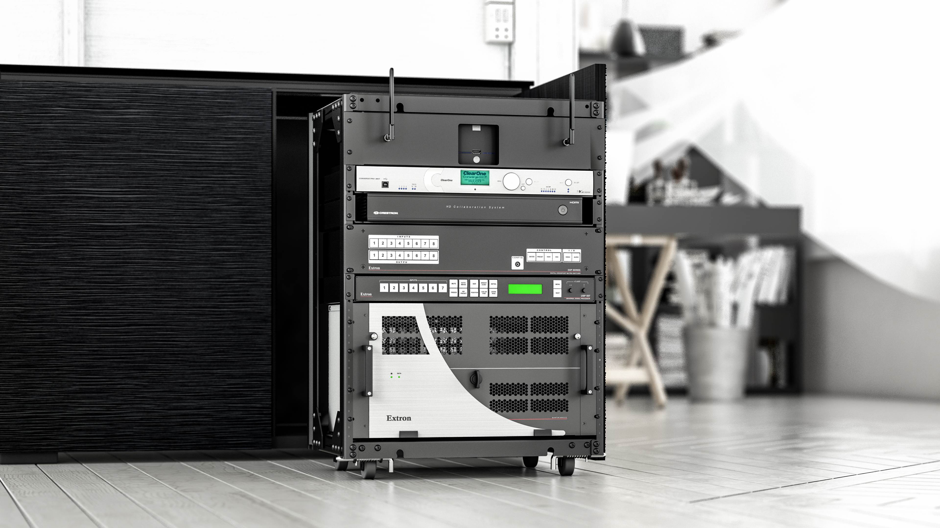
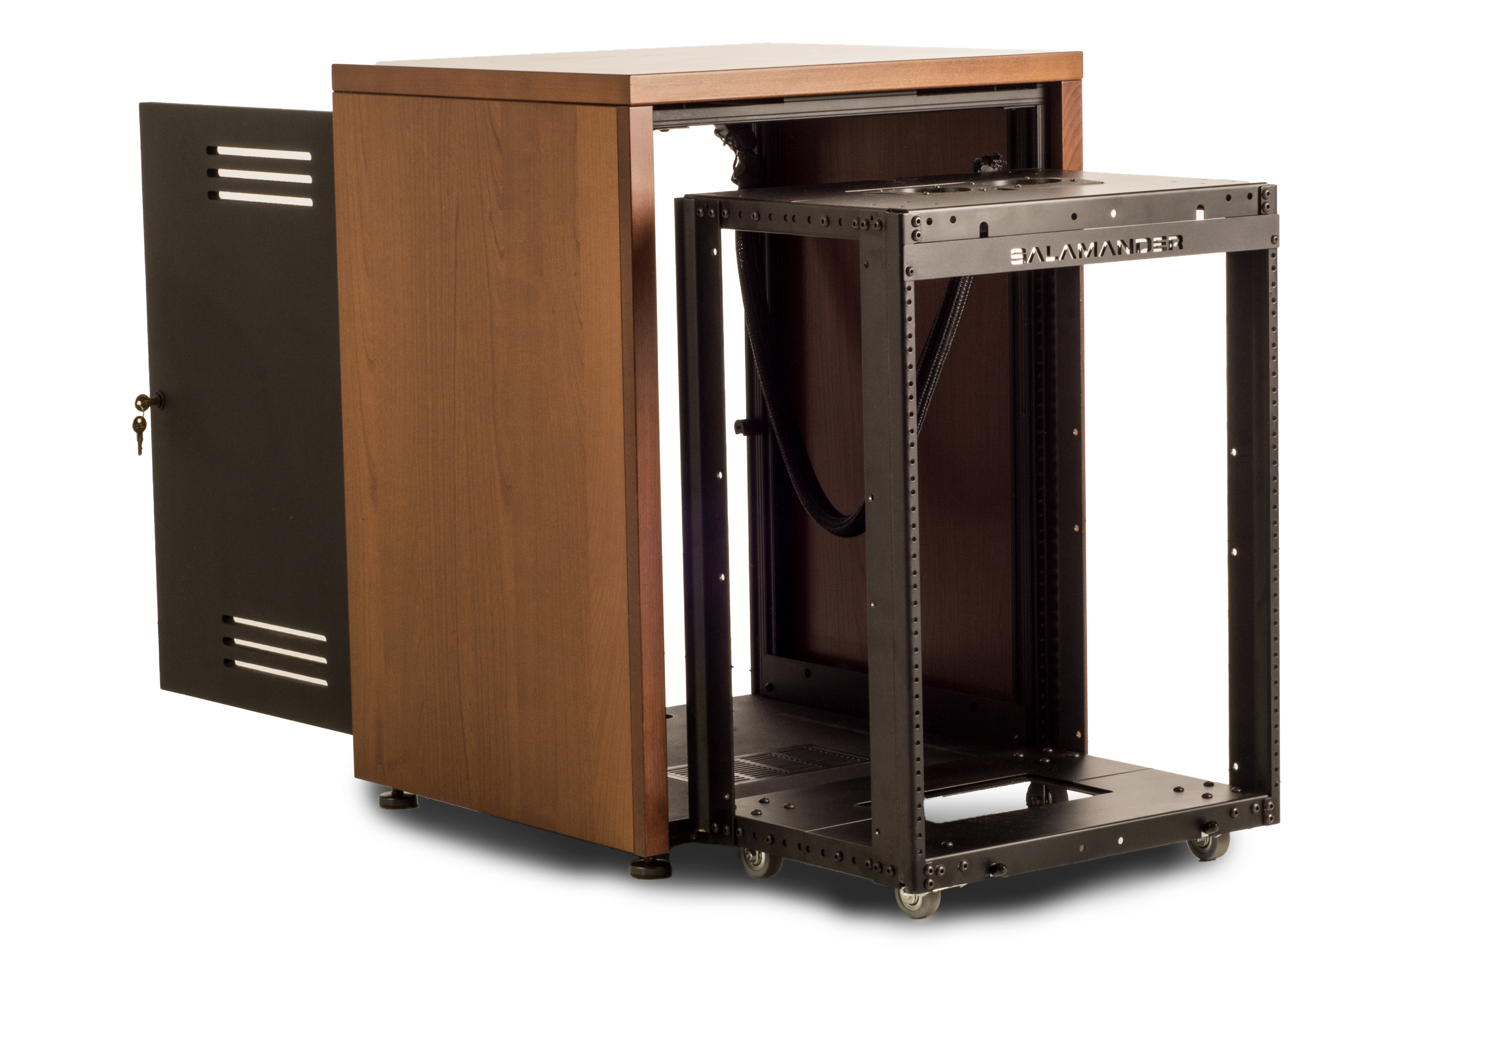
DOWNLOAD HI-RES PHOTOS & SPEC SHEETS HERE
About Salamander Designs: Salamander Designs is a leading manufacturer of premium quality, highly customizable furniture for residential and commercial audio/video integration. Known for fusing visual design with functional engineering and advanced manufacturing methods, Salamander’s innovative product lines feature a wide range of furniture solutions, enabling AV enthusiasts and integrators to meet every present and future need. www.salamanderdesigns.com
Media Contact:
Christopher J. Sparks
c.sparks@salamanderdesigns.com - 860-761-9522 (x922)

