FOR IMMEDIATE RELEASE

Salamander Releases Refined Entertainment Seating
Bloomfield, CT - October 6, 2015 - Salamander Designs, Ltd., (CEDIA Booth #2512) the leader in premium A/V furniture for over 20 years, has expanded its entertainment seating line with the Isabella Collection. The Isabella Collection is a premium, handmade seating lineup for home theater enthusiasts using carefully selected materials and including luxurious features for discerning consumers. The Salamander Isabella Collection will become available November 1, 2015.

Isabella, traditional styling with modern comfort
Heads turn when Isabella’s in the room. Indulge. Pamper yourself, friends and family with high-end luxury home entertainment seating on a grand scale. Updated traditional style with fine tailoring and subtle curves beckon from all angles. Obsessive attention to detail shows in the precise stitching, tailored piping, handsome roll arms and advanced ergonomics. Enjoy staying in.
Isabella provides the features users expect from theater seating—such as chair modules with optional cup holders and a choice of motorized, manual or non reclining backs—with the inviting comfort of an elegant sofa. Isabella is available in a range of materials and thanks to Salamander’s new Custom Details program, customers can choose from a huge variety of leathers and select matching or contrasting piping.
“Our dealers have expressed a need for premium theater seating solutions,” explained Salamander President Salvatore Carrabba. “We have developed a deeper, richer take on traditional style with modern comfort and accessories for the client of discerning tastes.” Carrabba added.

Salamander Quick-Ship Program
Our 15-Day Quick-Ship program lets you enjoy your new entertainment space sooner – not later. Built completely in the USA to meticulous quality standards, Isabella seating is backed by a limited lifetime warranty and dependable customer service.
Stop by the Salamander Designs CEDIA Booth #2512 to discover functional and luxurious designs with quality materials, all engineered to perform and with attention to every detail.

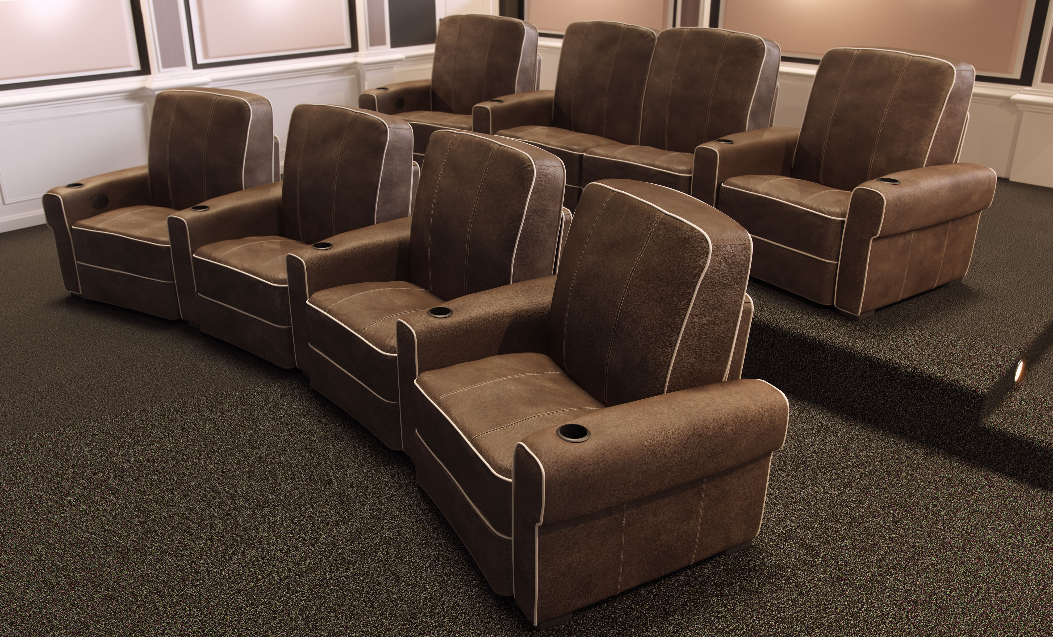

Download Hi-Res Images & Spec Sheet Here
About Salamander Designs Salamander Designs is a leading manufacturer of premium quality, highly customizable furniture for residential and commercial audio/video integration. Known for fusing visual design with functional engineering and advanced manufacturing methods, Salamander’s innovative product lines feature a wide range of furniture solutions, enabling AV enthusiasts and integrators to meet every present and future need.

Media Contact
Christopher J. Sparks c.sparks@salamanderdesigns.com 860.761.9522 x522

